*Seyedamin Seyedmahmoudian*

*040813340 | CST8333 Programming Language Research Project*

*Programmer Technical Overview*

Table of Contents

Variable Deceleration: 3

Decision Structures: 3

Methods: 4

Object: 4

Modules: 5

Exception Handling: 5

File IO: 6

API: 6

Database Connectivity 6

Figure 1 Variable Deceleration 3

Figure 2 Decision Structures 3

Figure 3 Python methods 4

Figure 4 Creating object of API class pandas 4

Figure 5 Modules in Python 5

Figure 6 Exception Handling 5

Figure 7 File IO in Python 6

Figure 8 API usage in Python 6

Figure 9 Database Connectivity 6

# 

# Variable Deceleration:

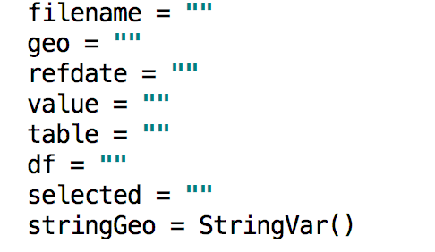

Figure 1 Variable Deceleration

Figure 1: Python does not have data type like in Java or C for instance in above code filename which will contain the name of the file can be used as a string and if the programmer wants it can change the data in it to a digit.

# Decision Structures:

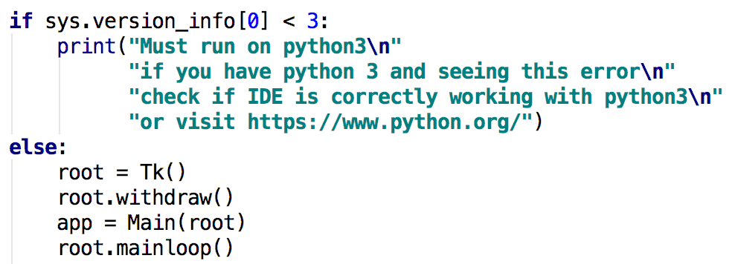

Figure 2 Decision Structures

Figure 2: Demonstrate a simple if and else statement to check for Python version of the operating system if the Python version is not at least 3 it will stop the project and print a message asking the user to download and install the correct version.

# Methods:

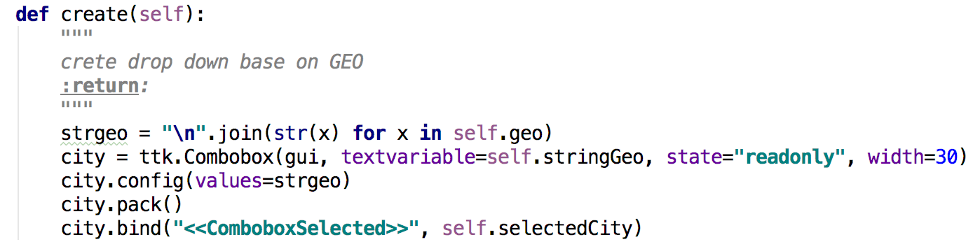

Figure 3 Python methods

Figure 3: A simple function in python in order to declare function in Python the code must start with keyword “def” followed by the function name and parentheses. Here we are passing self which is object of the class that calls the function

# Object:

Screen%20Shot%202017-12-17%20at%204.04.19%20PM.png

Screen%20Shot%202017-12-17%20at%204.03.59%20PM.png

Figure 4 Creating object of API class pandas

Figure 4: Demonstration of how we can import a class and create object of that class, and pass argument to the constructor of the class.

# Modules:

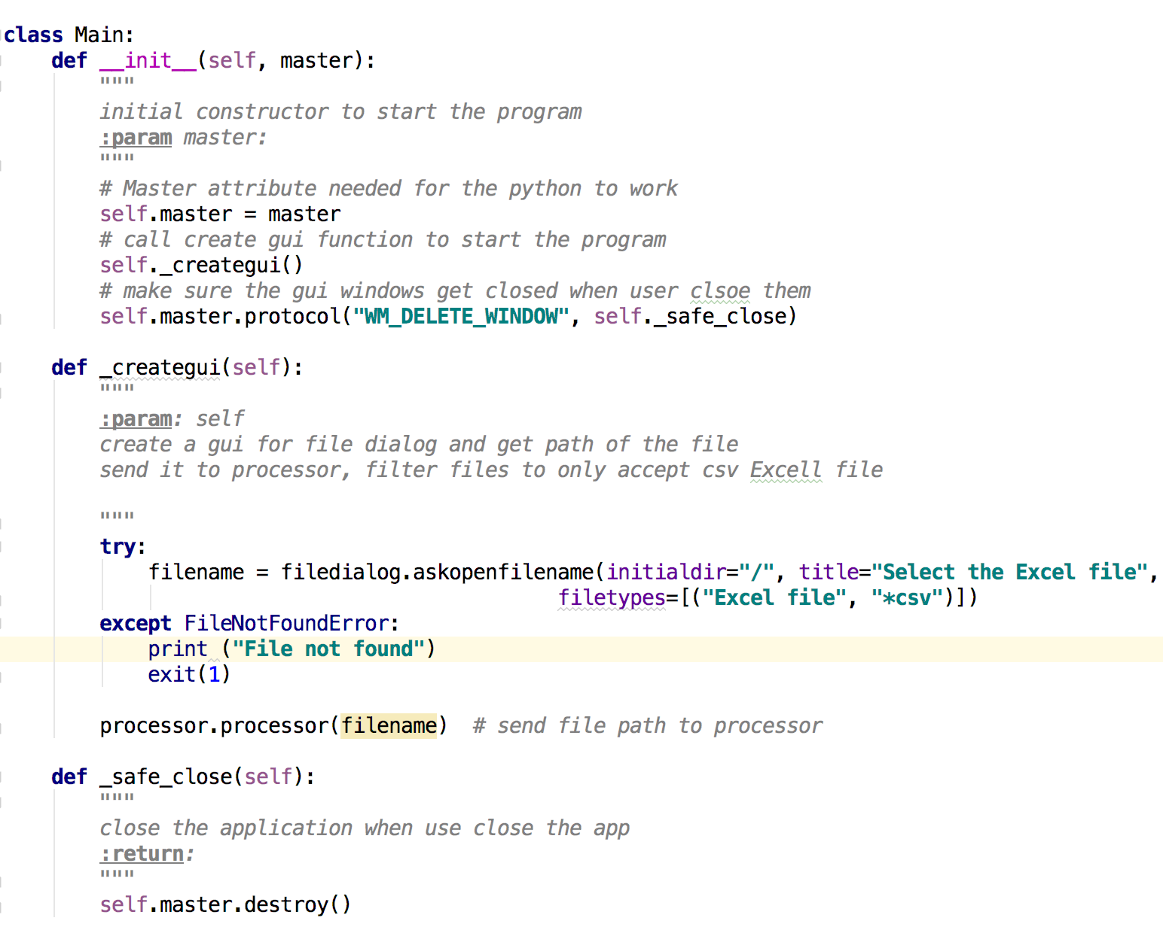

Figure 5 Modules in Python

Figure 5: Demonstrate how modules work in Python, in other word all classes in Python are modules and in order to create one need the keyword “class” followed by the class name.

# Exception Handling:

# Screen%20Shot%202017-12-16%20at%2011.22.09%20PM.png

Figure 6 Exception Handling

Figure 6: Demonstrate how we can handle exception in Python, in this example we check if the file exists or not.

# File IO:

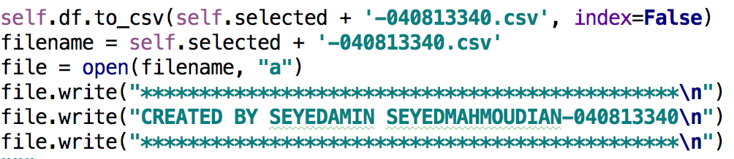

Figure 7 File IO in Python

Figure 7: Demonstrate how open the file, write all the data and add three extra line to the end of the file.

# API:

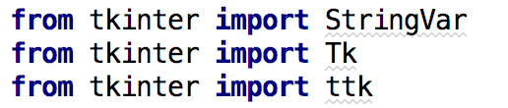

Screen%20Shot%202017-12-17%20at%204.17.48%20PM.png

Screen%20Shot%202017-12-17%20at%204.17.04%20PM.png

Figure 8 API usage in Python

Figure 8: Demonstrate how we can import and use Python native API in our case tkinter which generate graphical user interface.

Database Connectivity :

Screen%20Shot%202017-12-16%20at%2011.13.03%20PM.png

Figure 9 Database Connectivity

Figure 9: Panda table being used as a database which hold all the data in memory for future access in application. Although this is not a traditional SQL database but it can be considered a database hence it contains information needed for our application to work.